Stage 1:

sudo apt-get install libreadline-dev flex bison make gcc wget curl

curl -sSf <https://raw.githubusercontent.com/eXpOSNitc/expos-bootstrap/main/download.sh> | sh

cd $HOME/myexpos

make

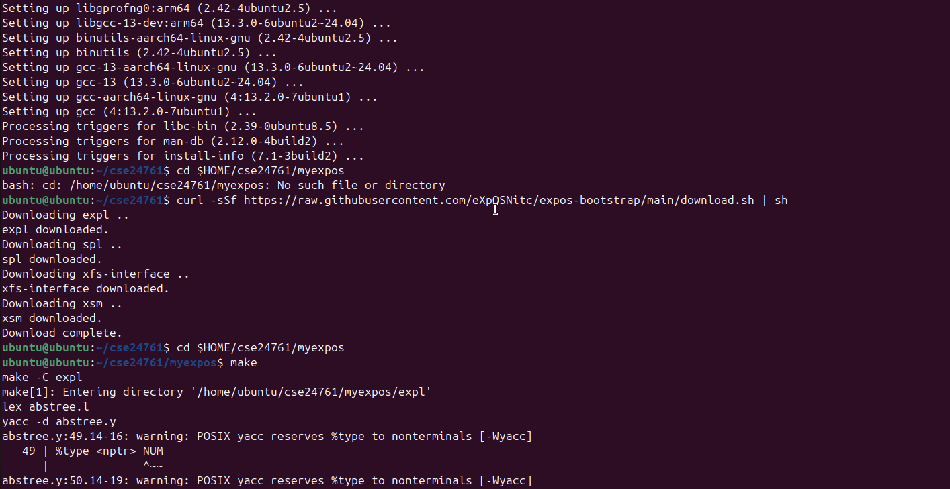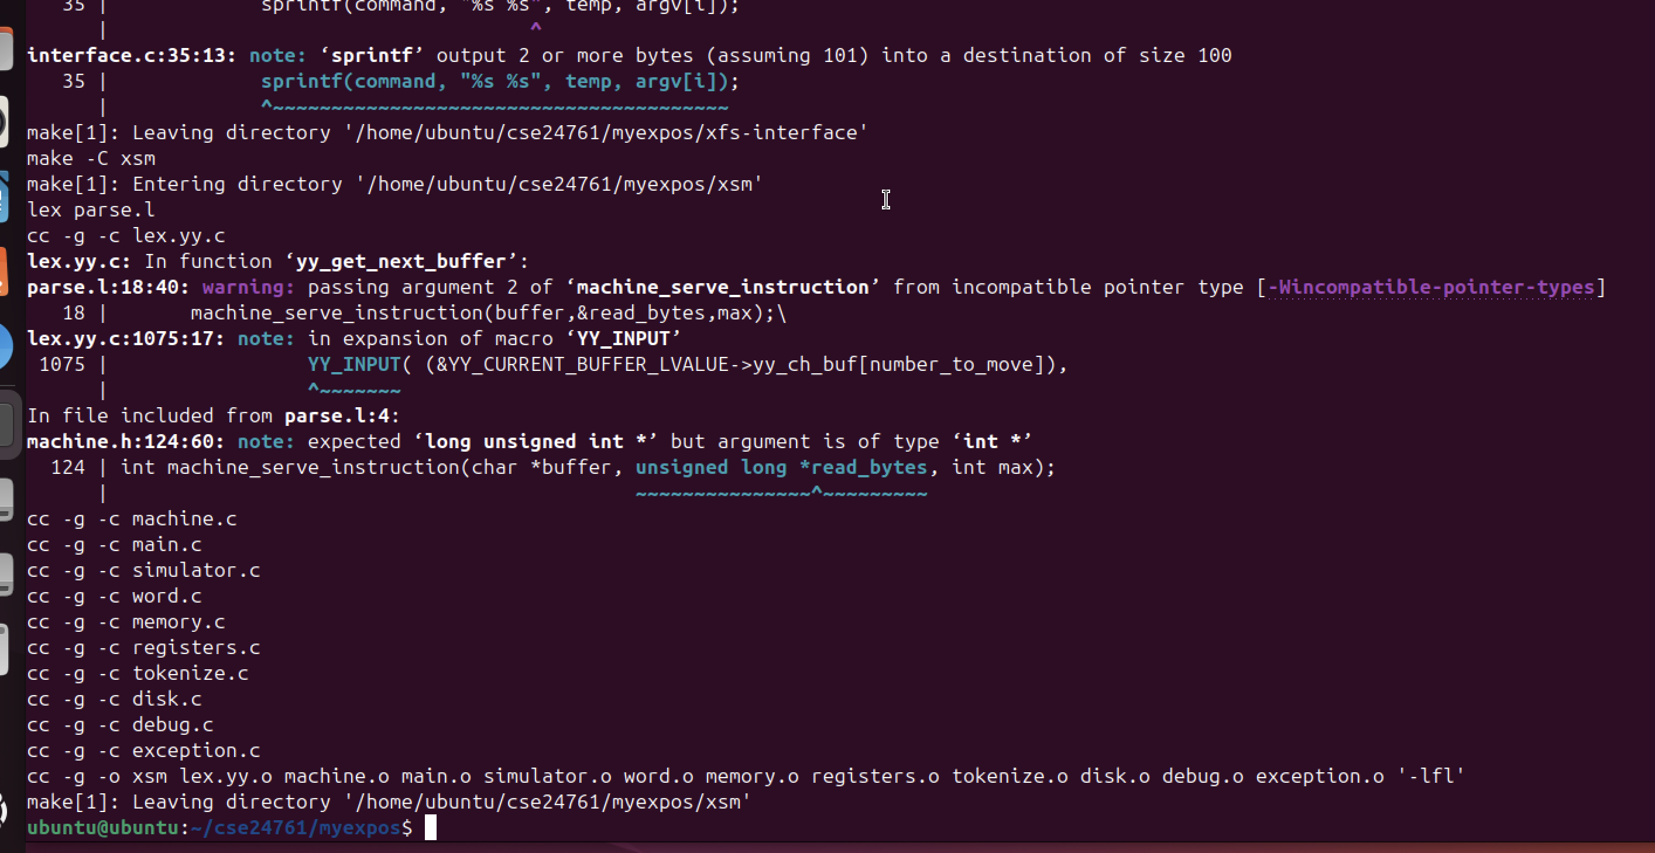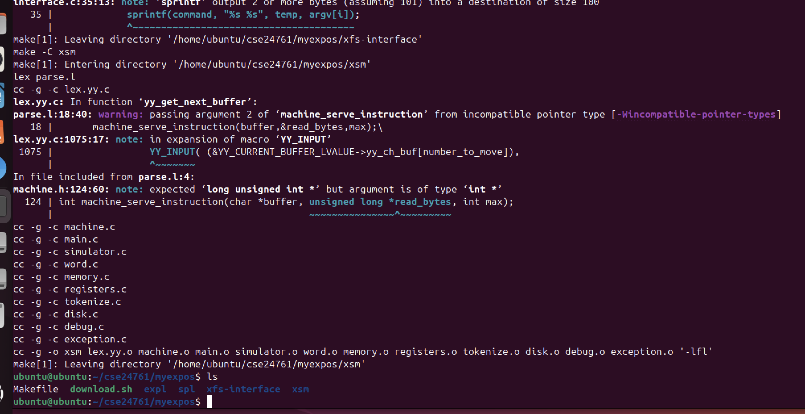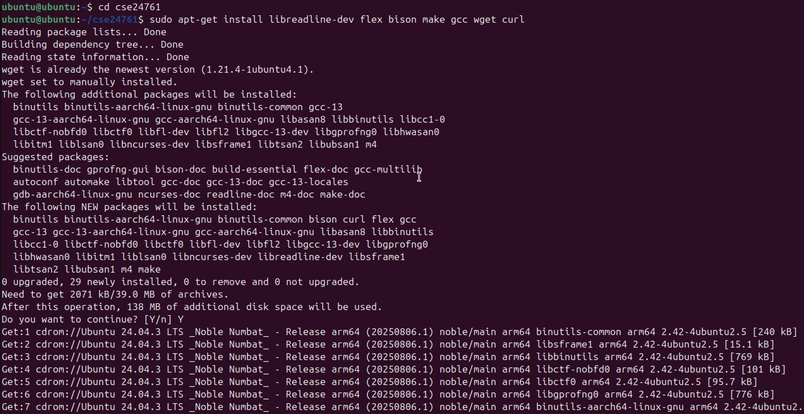

Stage 2:

ubuntu@ubuntu:~/cse24761/myexpos/xsm$ cd ..

ubuntu@ubuntu:~/cse24761/myexpos$ copy 3 4 ../inode_table.txt

Command 'copy' not found, did you mean:

command 'bcopy' from deb bacula-sd (9.6.7-7)

command 'fcopy' from deb fai-client (6.0.5ubuntu1)

command 'hcopy' from deb hfsutils (3.2.6-15build2)

command 'rcopy' from deb rdmacm-utils (48.0-1)

command 'mcopy' from deb mtools (4.0.43-1)

command 'copyq' from deb copyq (7.1.0-1)

command 'ropy' from deb libdisorder-tools (0.0.2+git20130809.8062ee1-4)

Try: sudo apt install <deb name>

ubuntu@ubuntu:~/cse24761/myexpos$ cd xfs-interface

ubuntu@ubuntu:~/cse24761/myexpos/xfs-interface$ ./xfs-interface

Unix-XFS Interace Version 2.0.

Type "help" for getting a list of commands.

# copy 3 4 ../inode_table.txt

# exit

ubuntu@ubuntu:~/cse24761/myexpos/xfs-interface$ cd xfs-interface

bash: cd: xfs-interface: Not a directory

ubuntu@ubuntu:~/cse24761/myexpos/xfs-interface$ ./xfs-interface

Unix-XFS Interace Version 2.0.

Type "help" for getting a list of commands.

# # dump --inodeusertable

Unknown command "#". See "help" for more information.

# dump --inodeusertable

# copy 69 69 ../data.txt

# export sample.dat ../data.txt

# exit

ubuntu@ubuntu:~/cse24761/myexpos/xfs-interface$ ./xfs-interface

Unix-XFS Interace Version 2.0.

Type "help" for getting a list of commands.

# copy 5 5 ../root_file.txt

# copy 3 3 inode_before.txt

# copy 5 5 root_before.txt

# copy 2 2 dfl_before.txt

# rm sample.dat

# rm sample.dat

File 'sample.dat' not found!

# copy 5 5 inode_after.txt

# copy 3 3 inode_after.txt

# copy 5 5 root_after.txt

# copy 2 2 dfl_after.txt

# exit

ubuntu@ubuntu:~/cse24761/myexpos/xfs-interface$

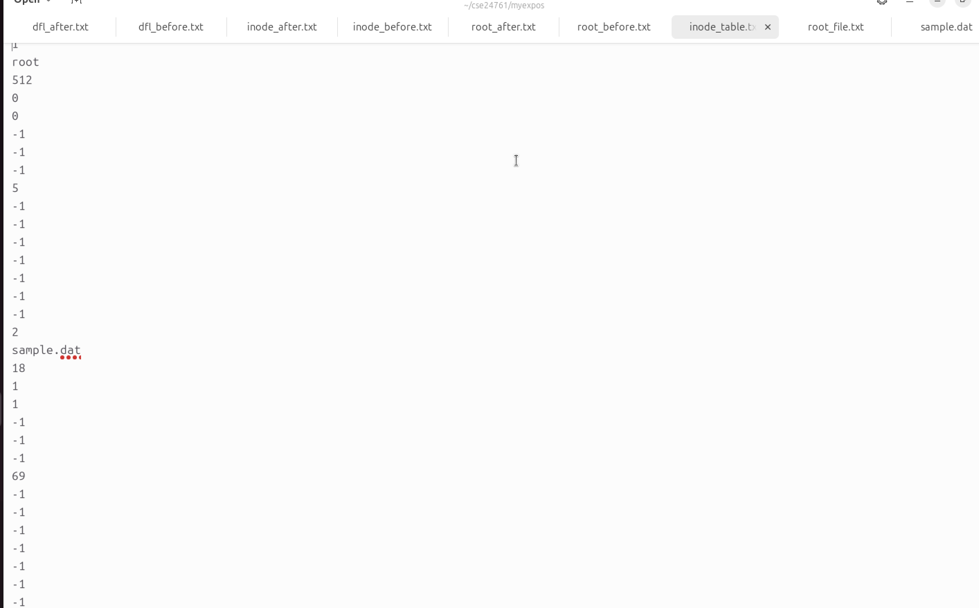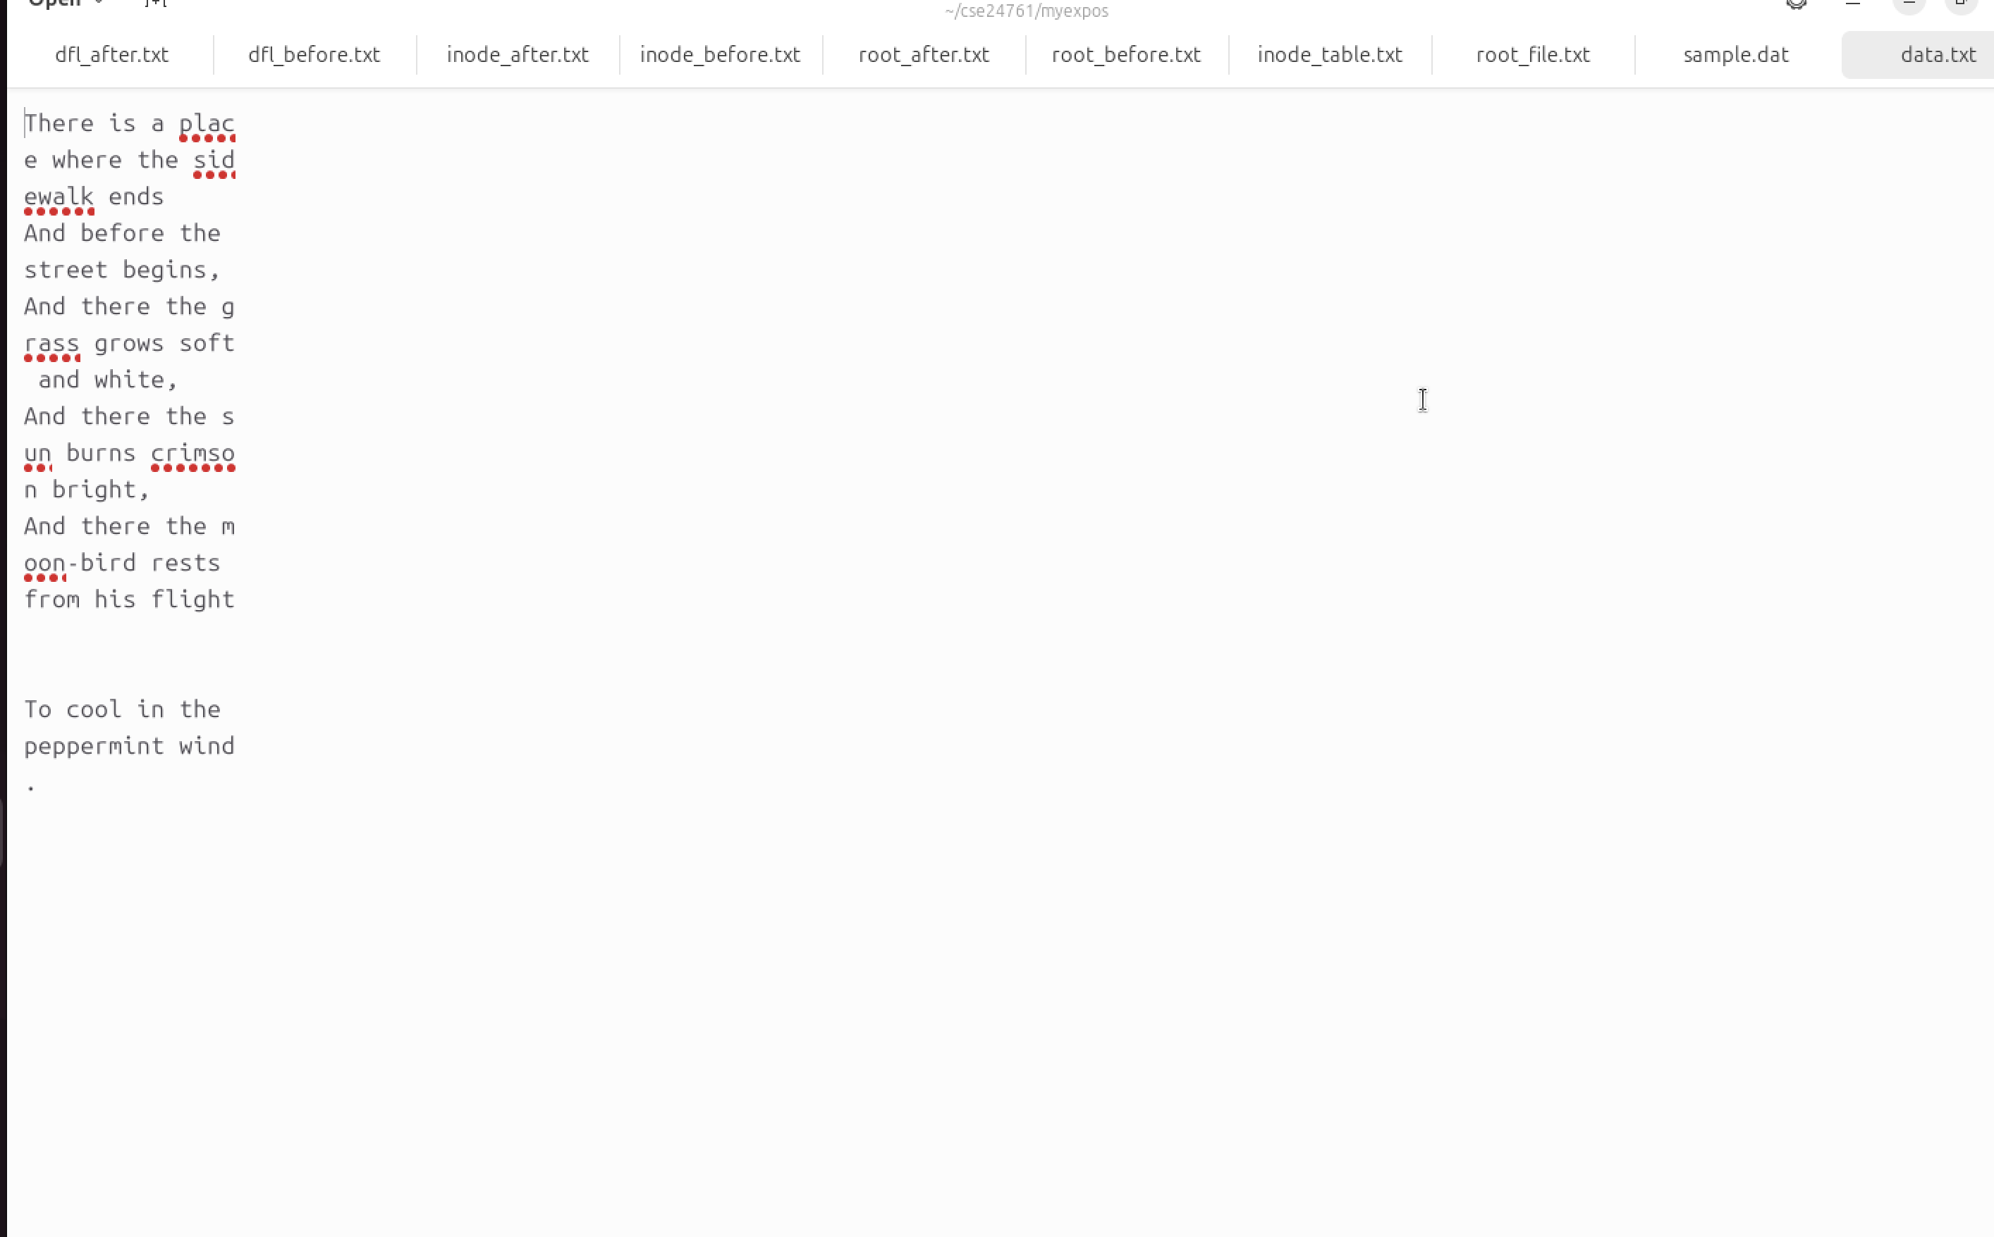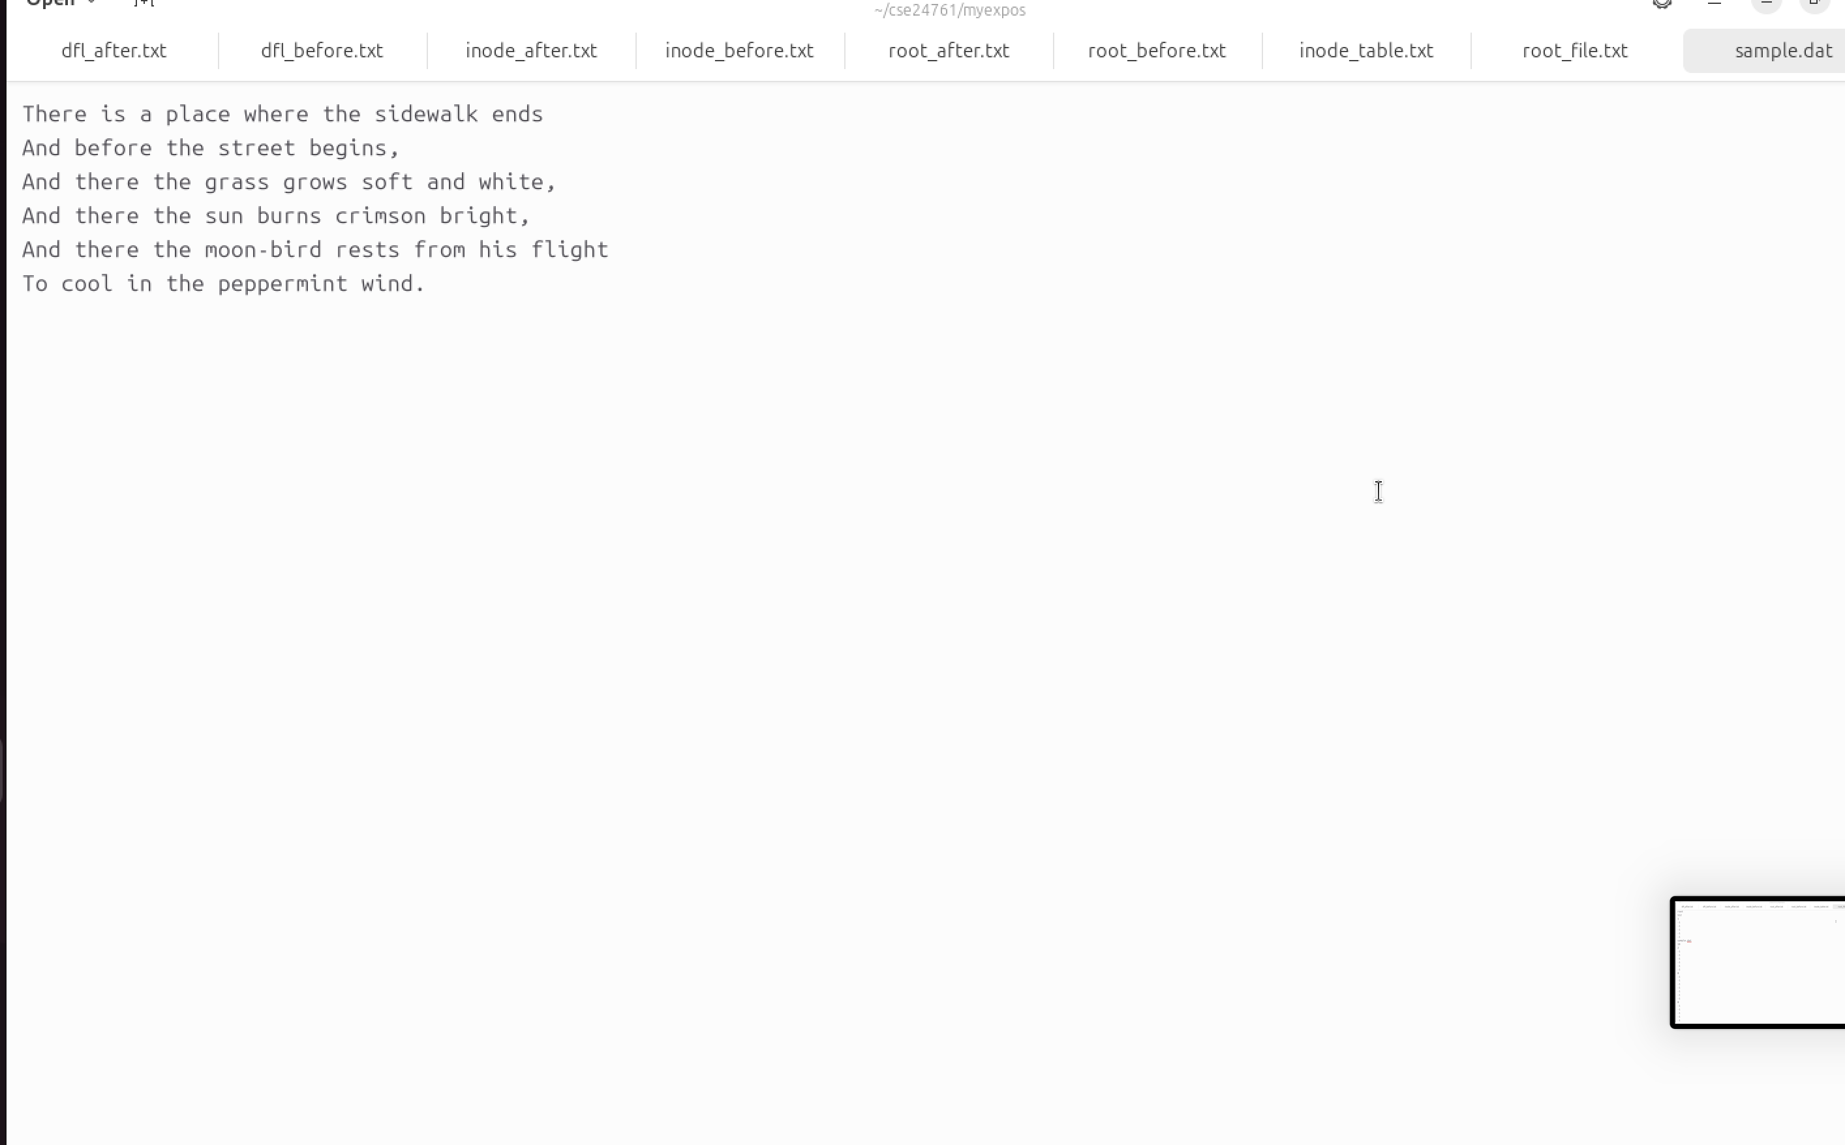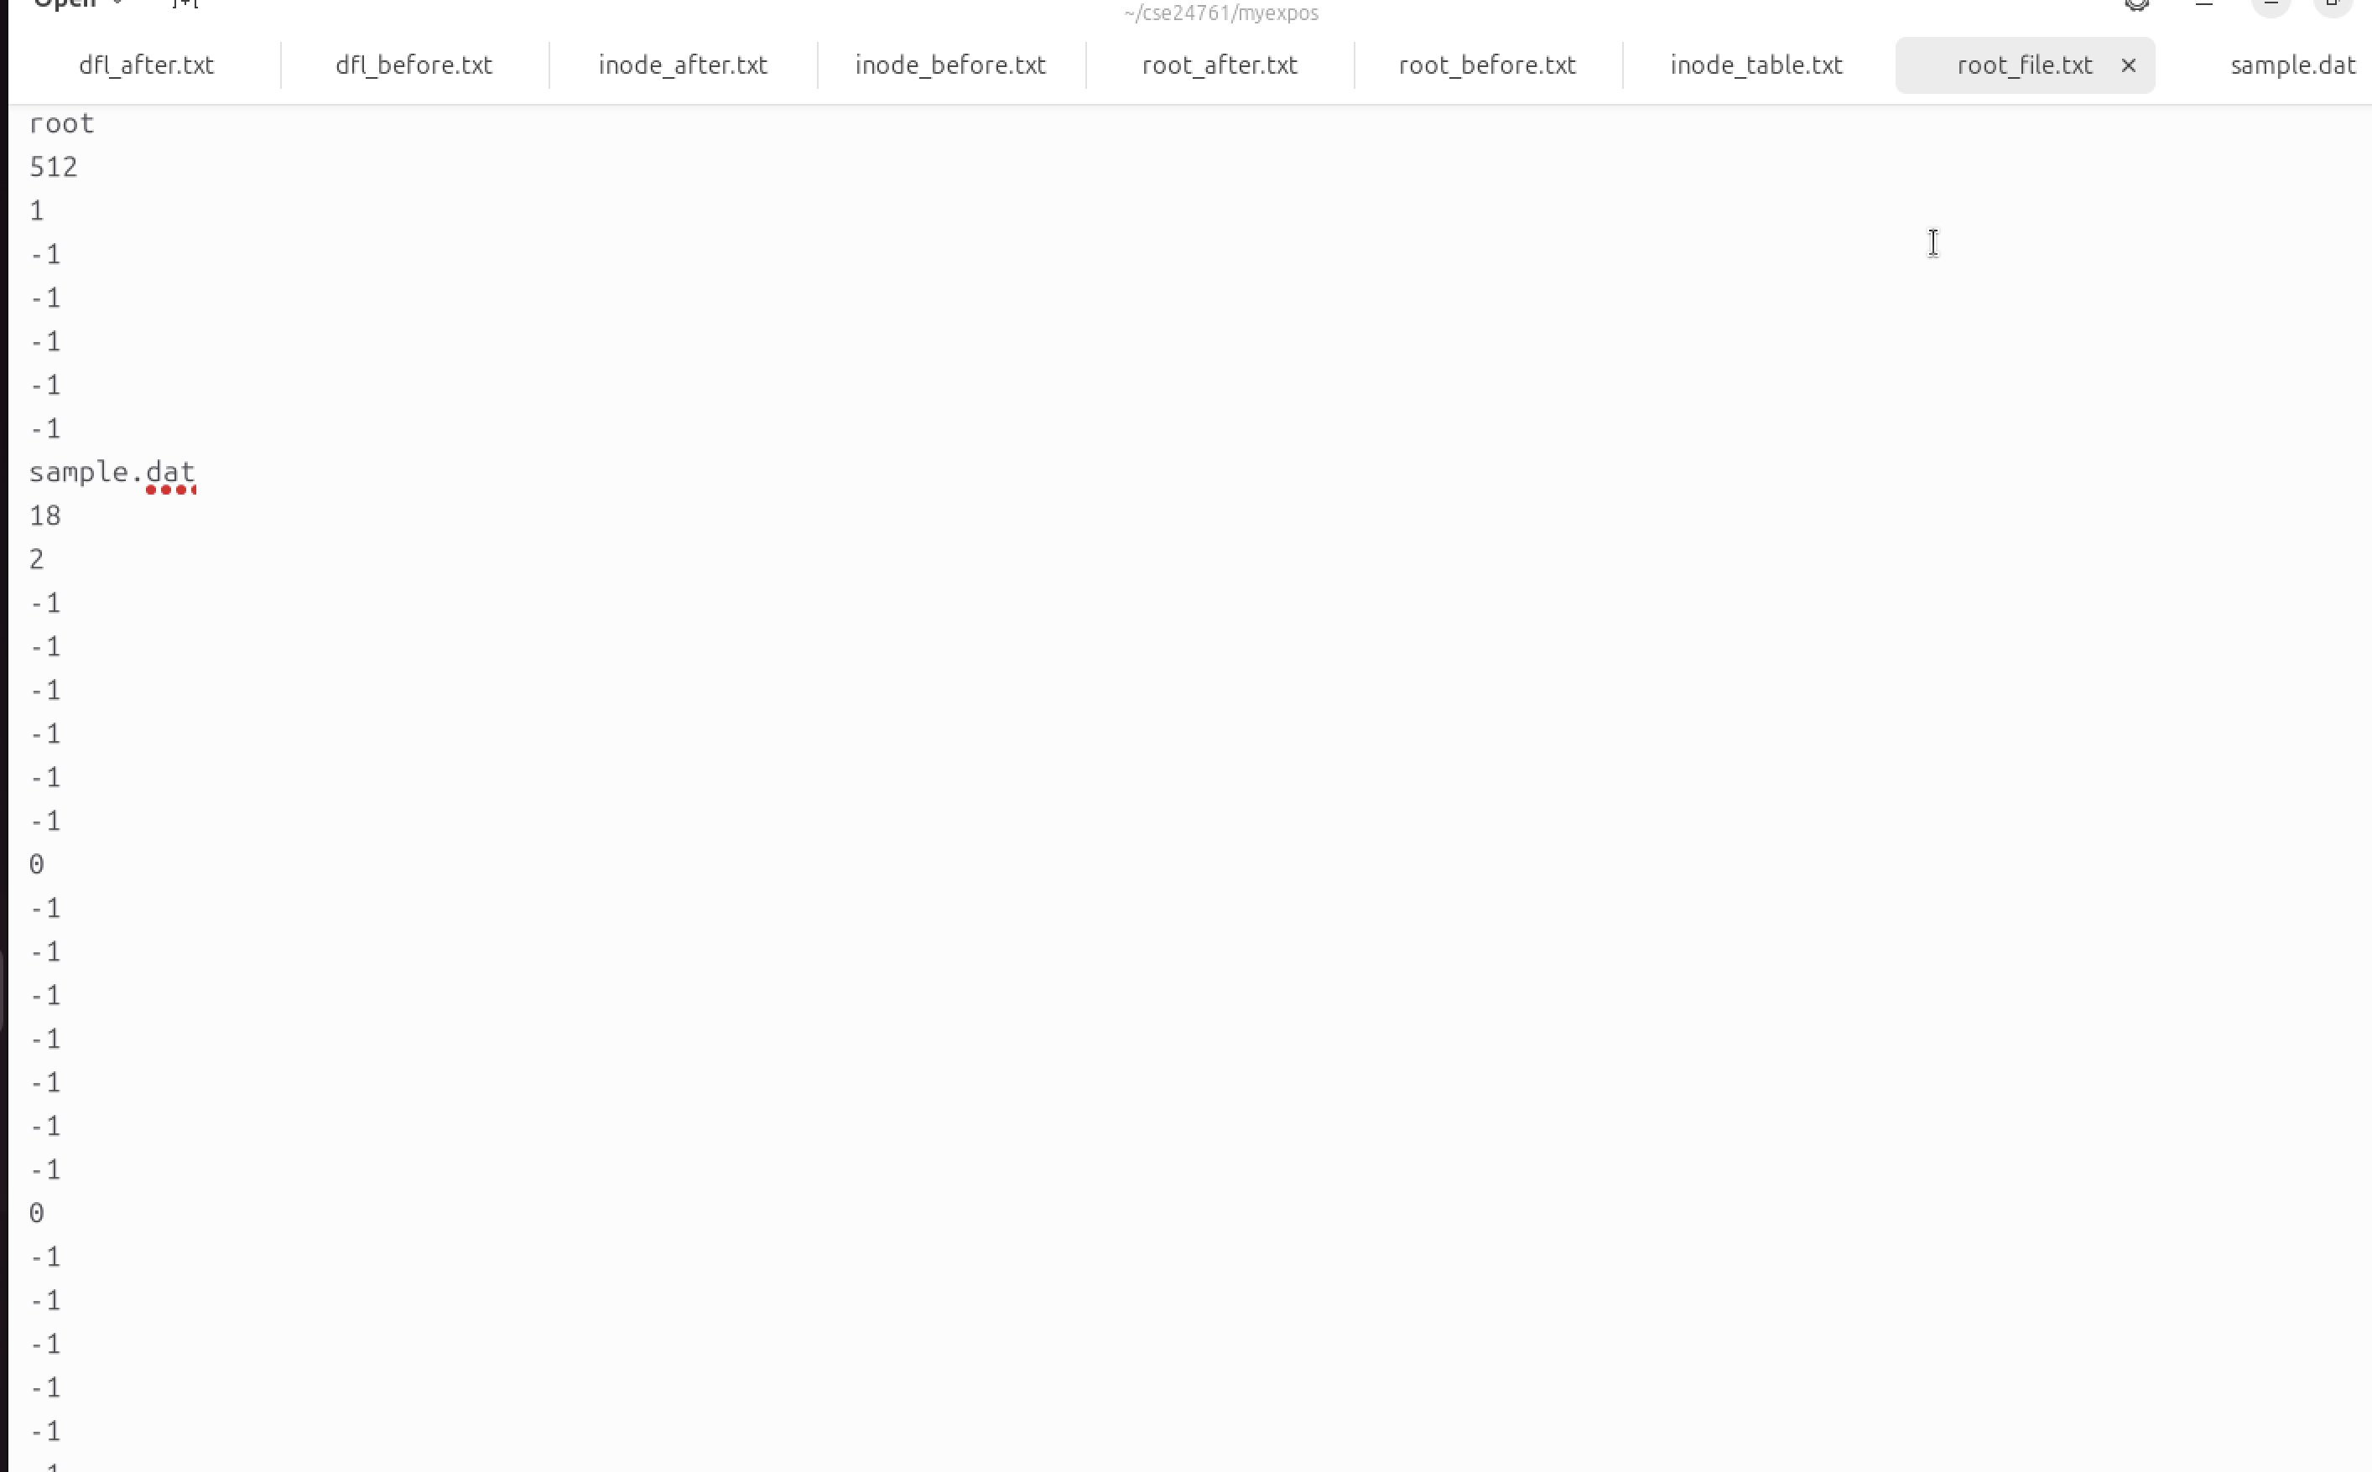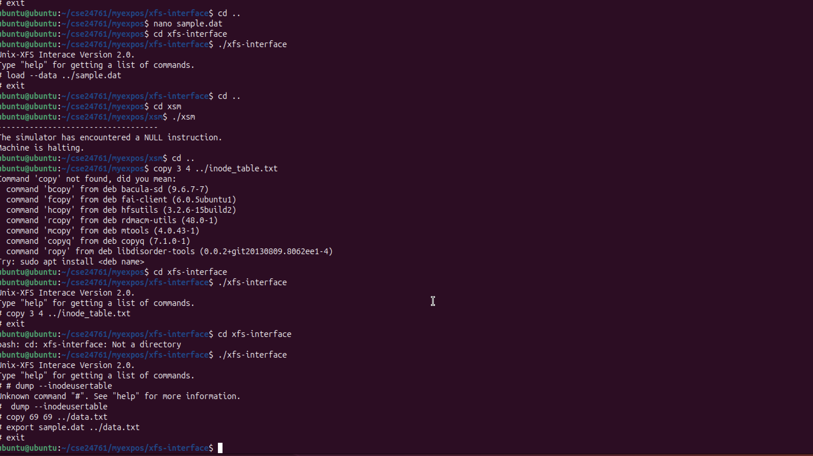

Assignment:

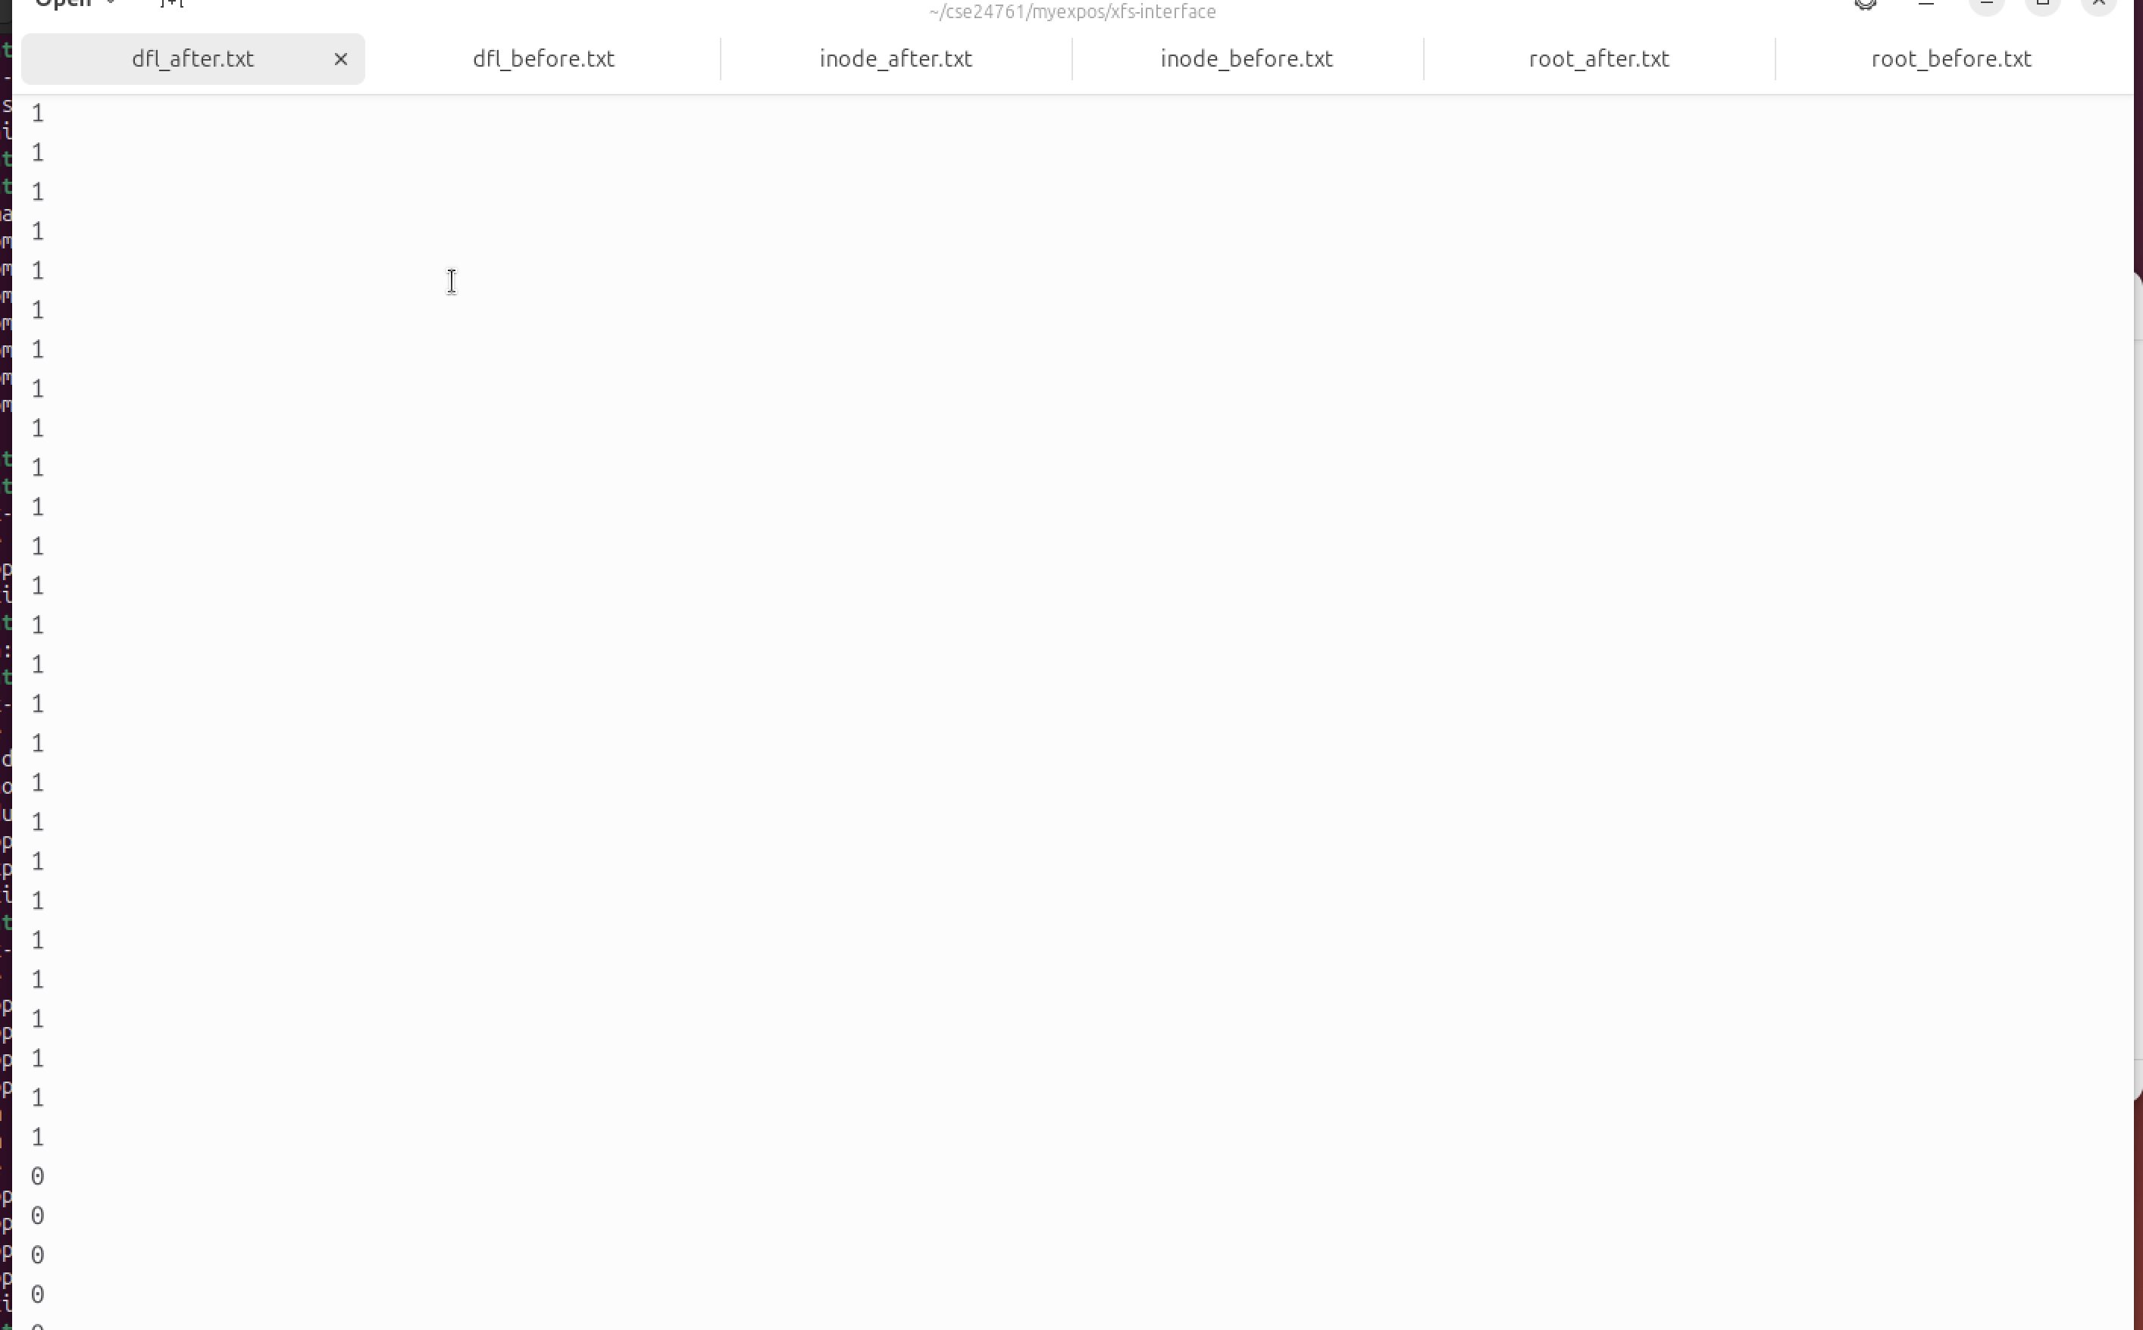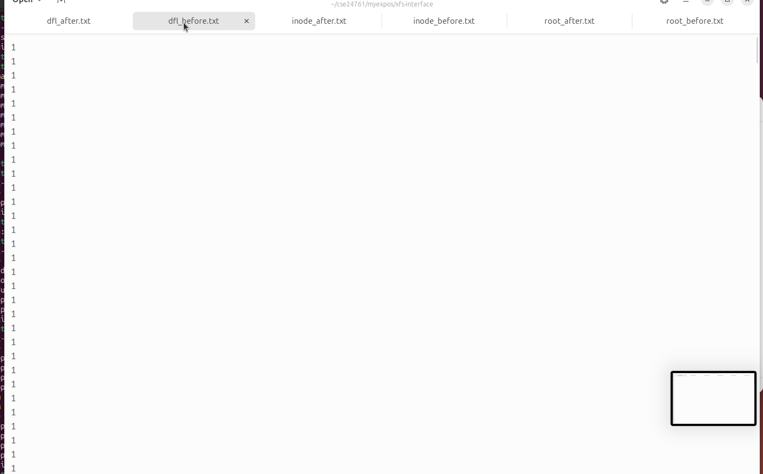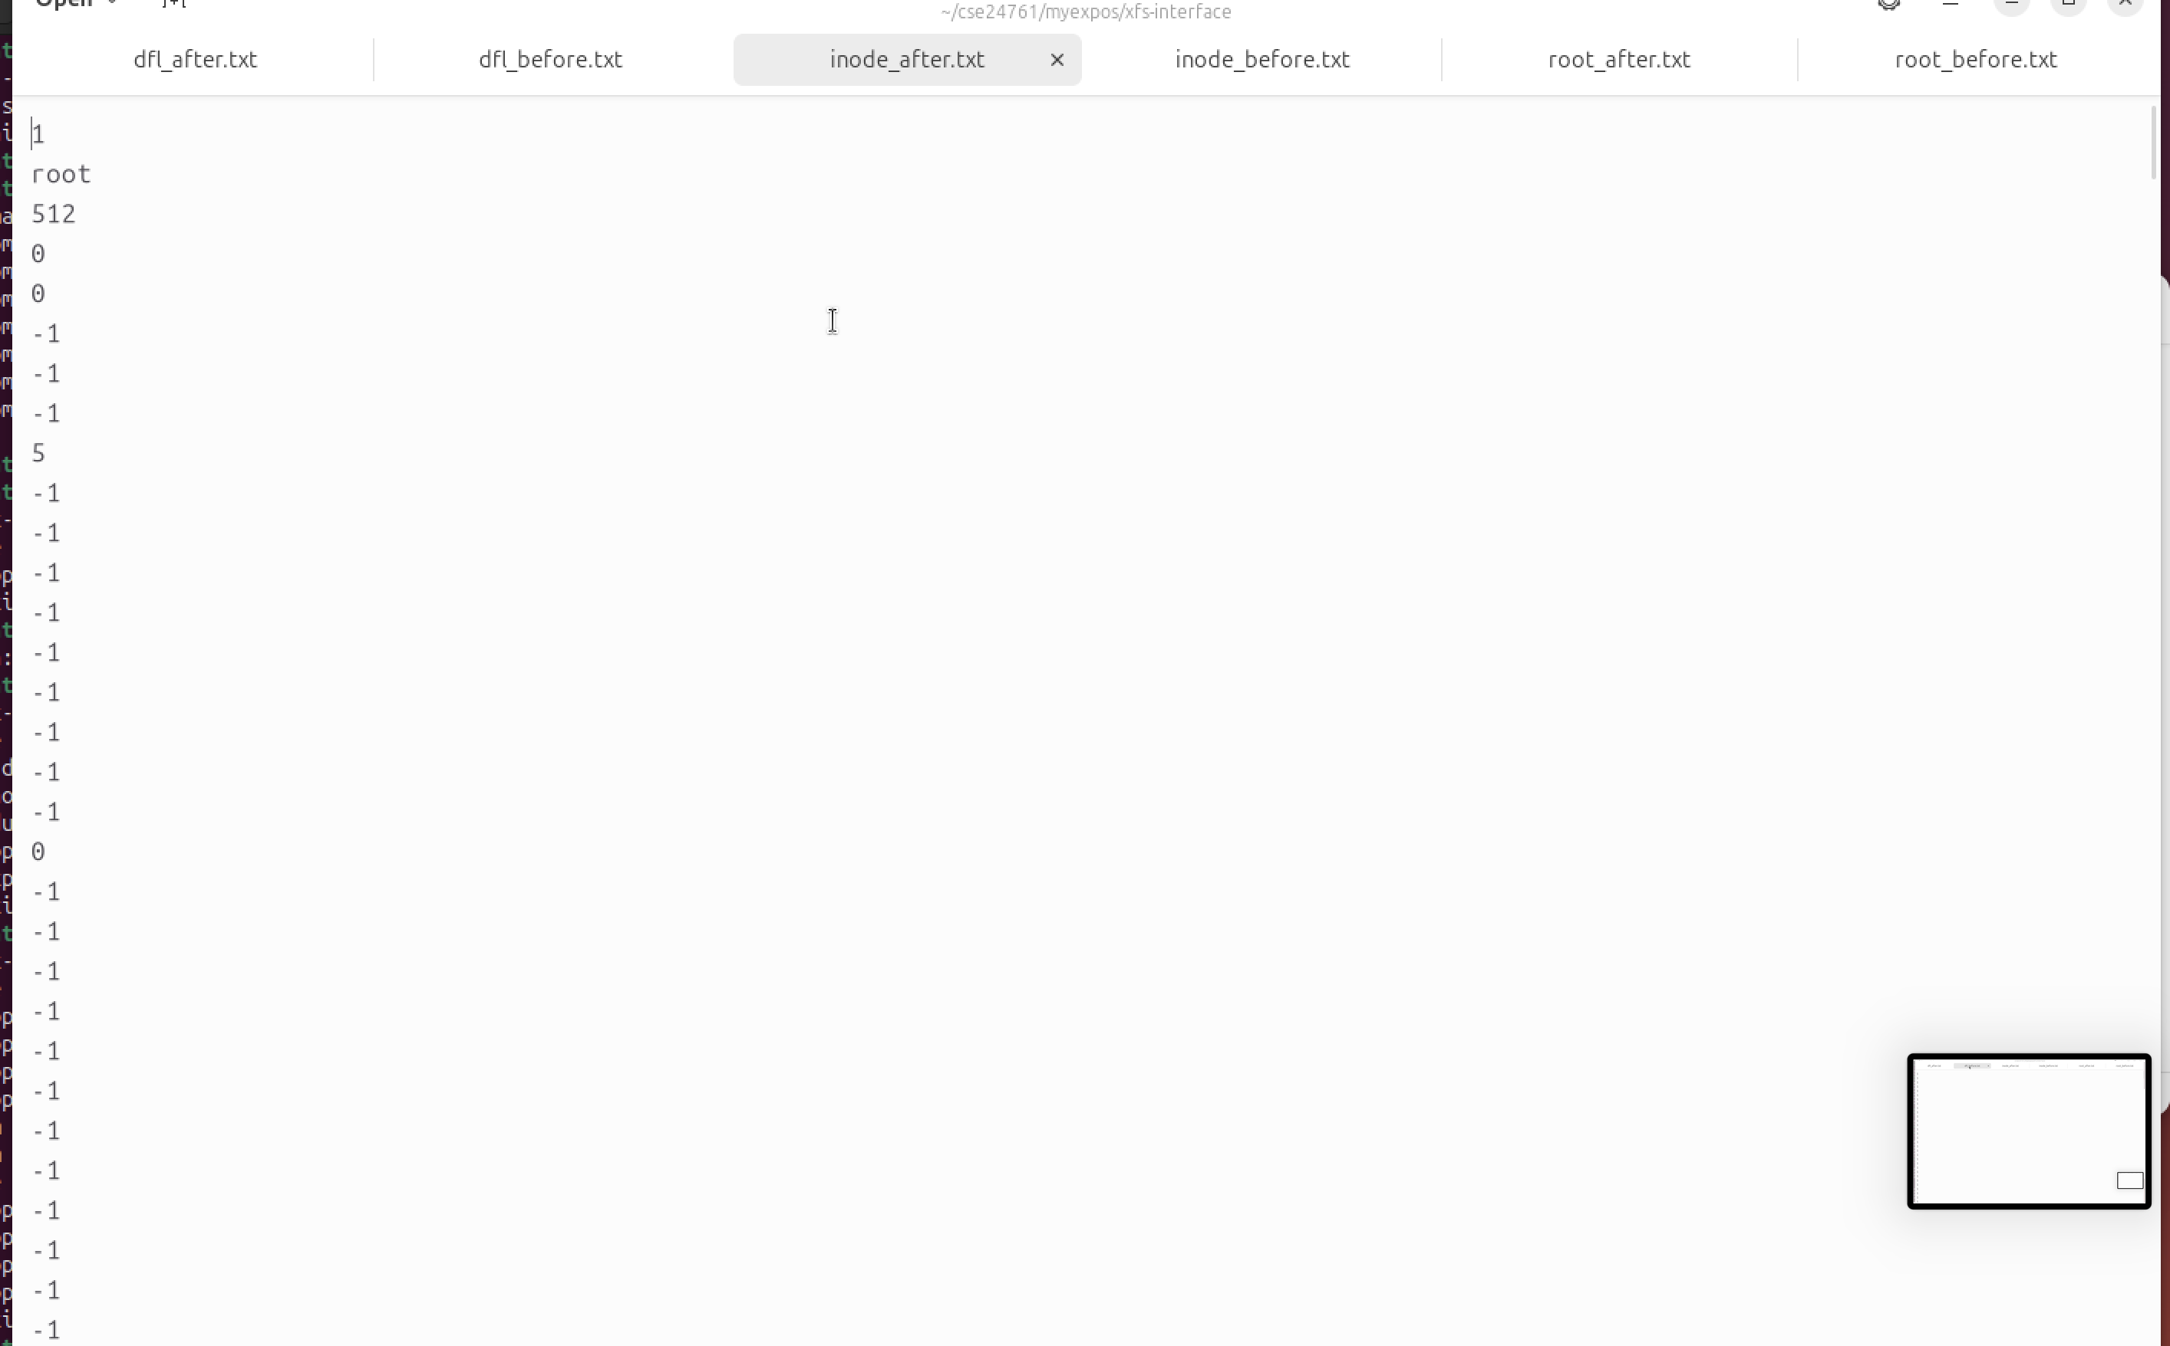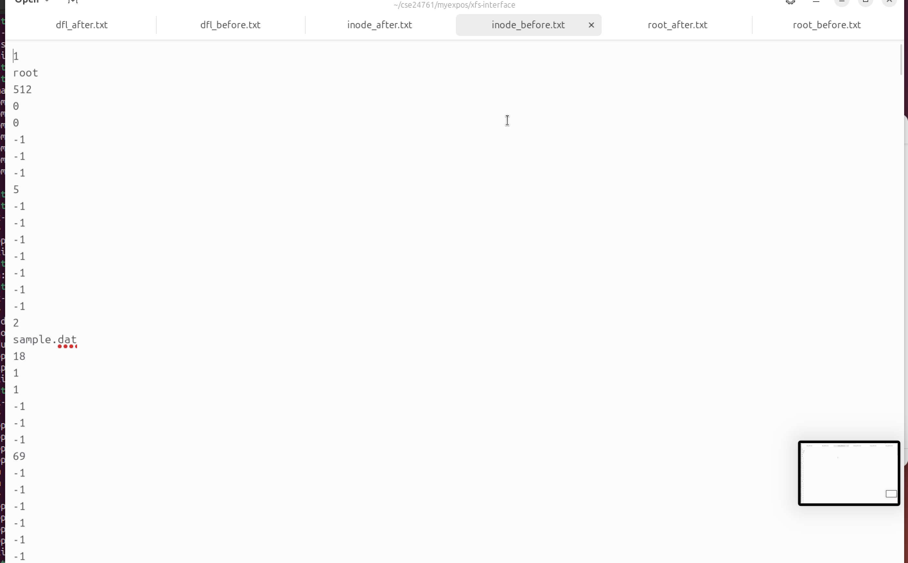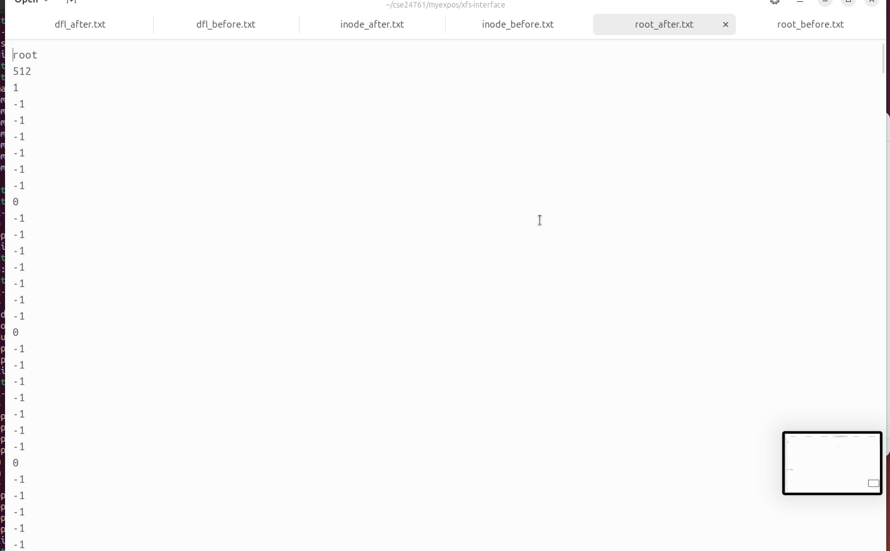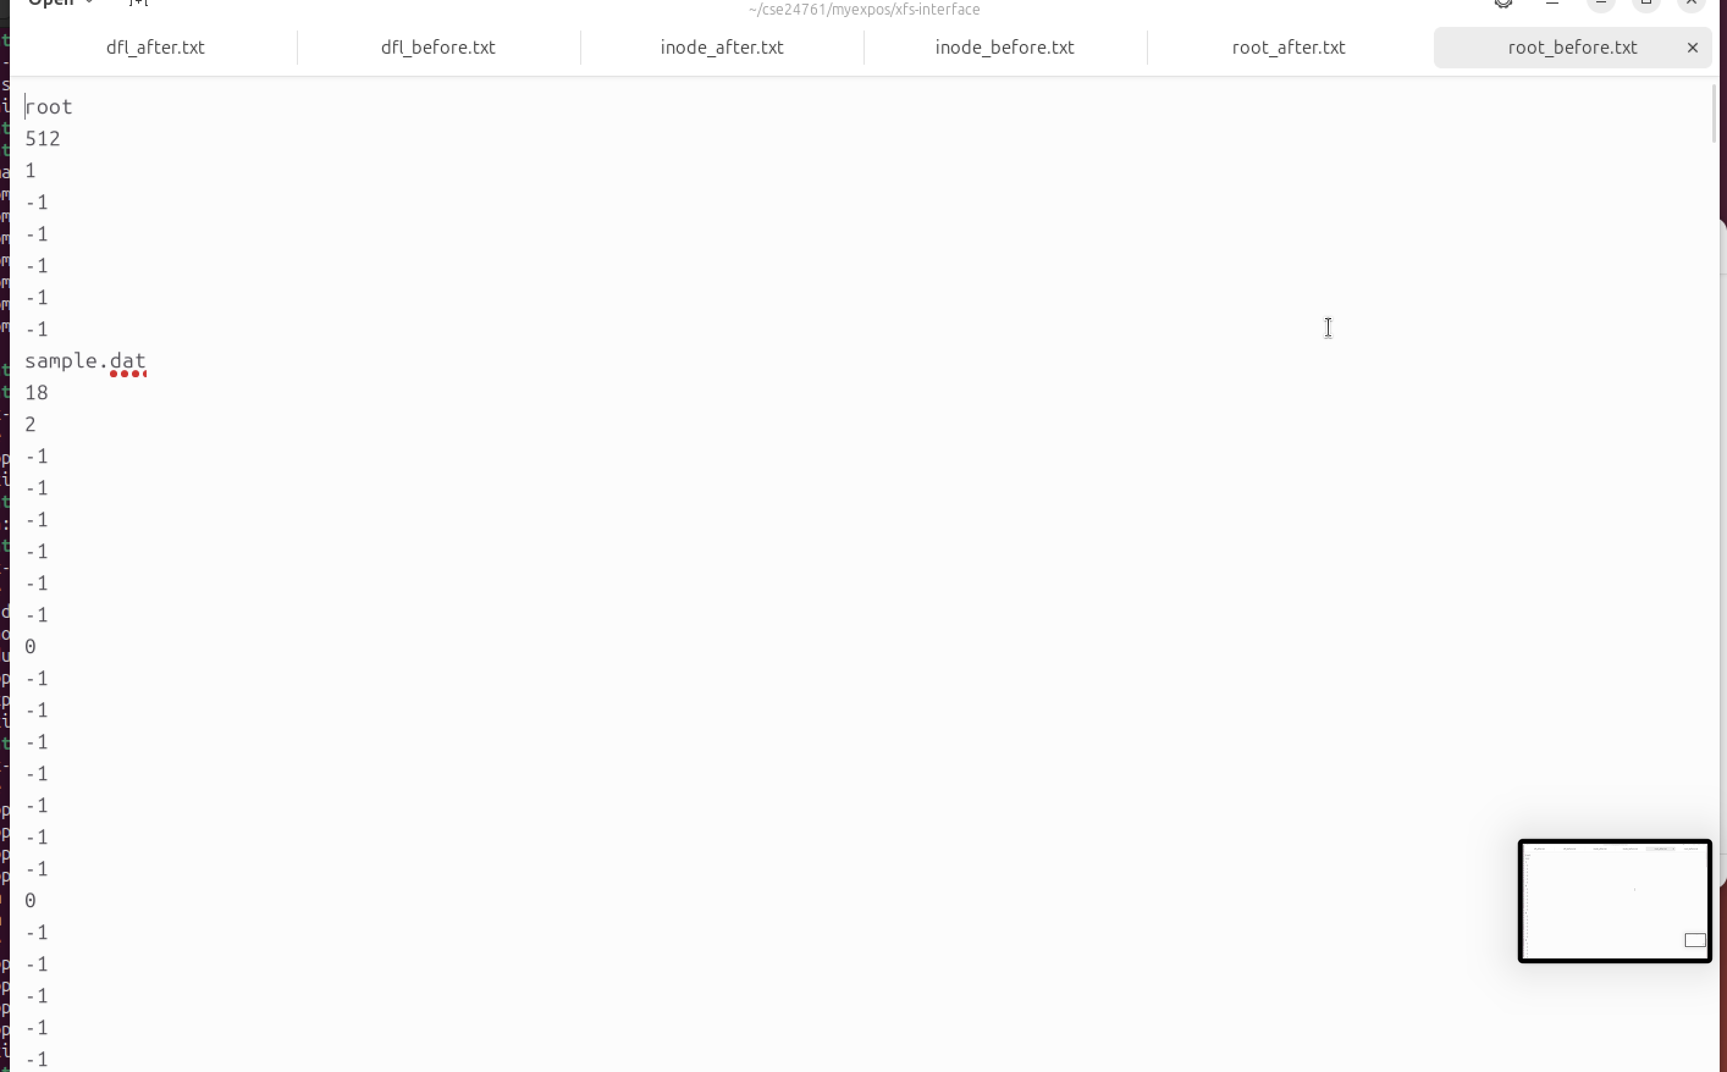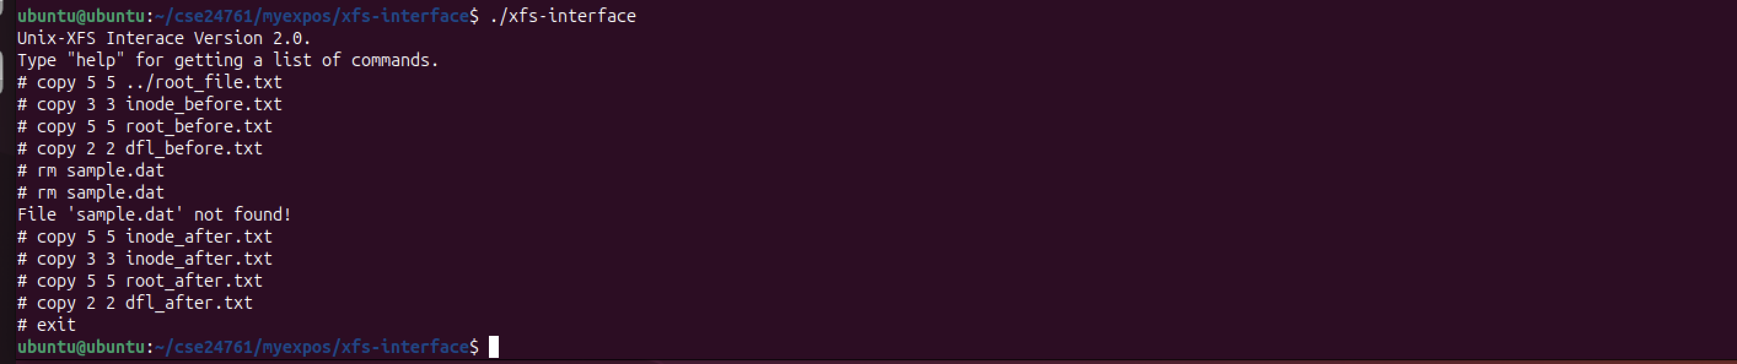

Stage 3:

ubuntu@ubuntu:~/cse24761/myexpos/xfs-interface$ cd ..

ubuntu@ubuntu:~/cse24761/myexpos$ cd spl

ubuntu@ubuntu:~/cse24761/myexpos/spl$ cd spl_progs

bash: cd: spl_progs: No such file or directory

ubuntu@ubuntu:~/cse24761/myexpos/spl$ cd spl_progs

bash: cd: spl_progs: No such file or directory

ubuntu@ubuntu:~/cse24761/myexpos/spl$ mkdir spl_progs

ubuntu@ubuntu:~/cse24761/myexpos/spl$ cd spl_progs

ubuntu@ubuntu:~/cse24761/myexpos/spl/spl_progs$ nano helloworld.xsm

ubuntu@ubuntu:~/cse24761/myexpos/spl/spl_progs$ cd ..

ubuntu@ubuntu:~/cse24761/myexpos/spl$ cd ..

ubuntu@ubuntu:~/cse24761/myexpos$ cd xfs-interface

ubuntu@ubuntu:~/cse24761/myexpos/xfs-interface$ ./xfs-interface

Unix-XFS Interace Version 2.0.

Type "help" for getting a list of commands.

# load --os ../spl/spl_progs/helloworld.xsm

# exit

ubuntu@ubuntu:~/cse24761/myexpos/xfs-interface$ cd ..

ubuntu@ubuntu:~/cse24761/myexpos$ cd xsm

ubuntu@ubuntu:~/cse24761/myexpos/xsm$ ./xsm

HELLO_WORLD

Machine is halting.

ubuntu@ubuntu:~/cse24761/myexpos/xsm$ cd ..

ubuntu@ubuntu:~/cse24761/myexpos$ cd spl

ubuntu@ubuntu:~/cse24761/myexpos/spl$ cd spl_progs

ubuntu@ubuntu:~/cse24761/myexpos/spl/spl_progs$ nano printnum.xsm

ubuntu@ubuntu:~/cse24761/myexpos/spl/spl_progs$ cd ..

ubuntu@ubuntu:~/cse24761/myexpos/spl$ cd ..

ubuntu@ubuntu:~/cse24761/myexpos$ cd xfs-interface

ubuntu@ubuntu:~/cse24761/myexpos/xfs-interface$ ./xfs-interface

Unix-XFS Interace Version 2.0.

Type "help" for getting a list of commands.

# load --os ../spl/spl_progs/printnum.xsm

# exit

ubuntu@ubuntu:~/cse24761/myexpos/xfs-interface$ cd ..

ubuntu@ubuntu:~/cse24761/myexpos$ cd xsm

ubuntu@ubuntu:~/cse24761/myexpos/xsm$ ./xsm

1

2

3

4

5

6

7

8

9

10

11

12

13

14

15

16

17

18

19

20

Machine is halting.

ubuntu@ubuntu:~/cse24761/myexpos/xsm$

Hello world.xsm:

MOV R0, "HELLO_WORLD"

MOV R16, R0

PORT P1, R16

OUT

HALT

Printnum.xsm:

MOV R0, 1

_L1:

MOV R16, 20

GE R16, R0

JZ R16, _L2

MOV R16, R0

PORT P1, R16

OUT

MOV R16, R0

ADD R16, 1

MOV R0, R16

JMP _L1

_L2:

HALT

HALT

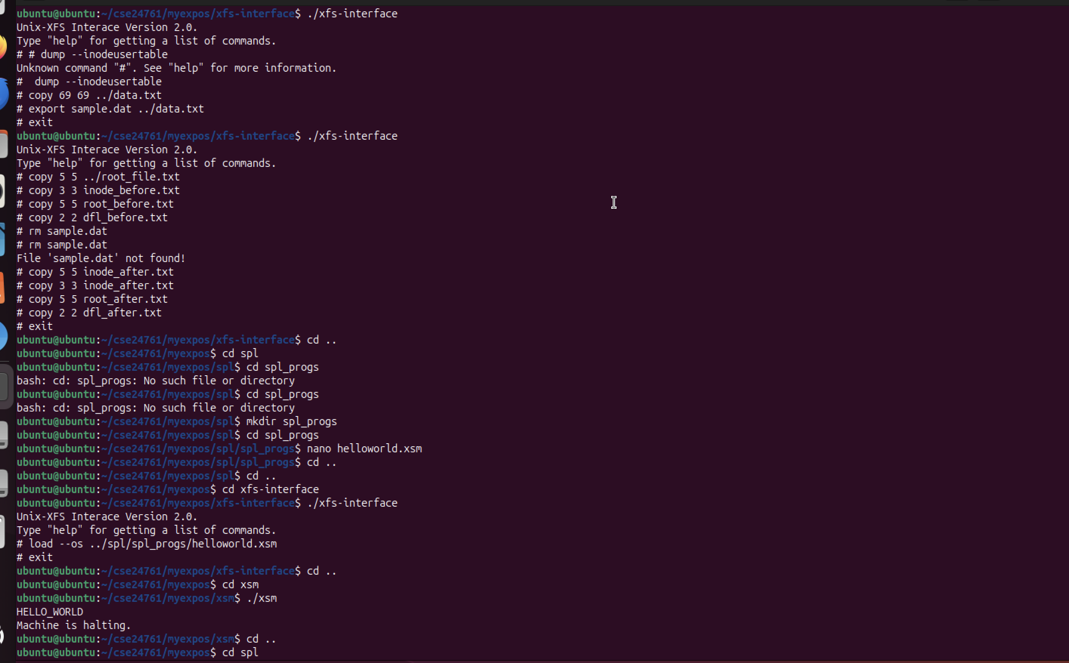

Assignment:

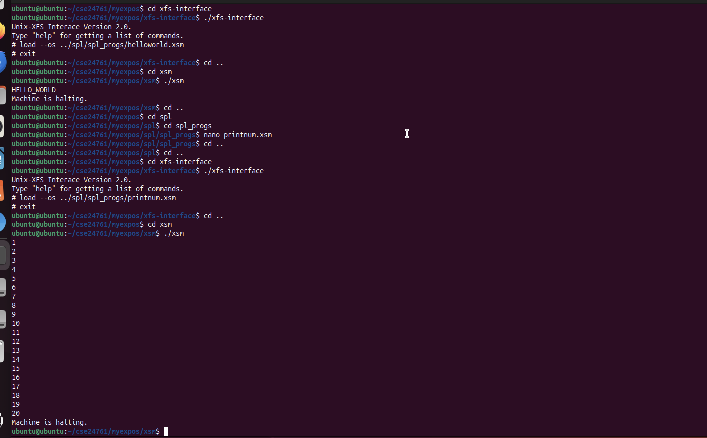

Stage 4:

ubuntu@ubuntu:~/cse24761/myexpos/xsm$ cd ..

ubuntu@ubuntu:~/cse24761/myexpos$ cd spl

ubuntu@ubuntu:~/cse24761/myexpos/spl$ cd spl_progs

ubuntu@ubuntu:~/cse24761/myexpos/spl/spl_progs$ nano oddnos.spl

ubuntu@ubuntu:~/cse24761/myexpos/spl/spl_progs$ cd ..

ubuntu@ubuntu:~/cse24761/myexpos/spl$ ./spl spl_progs/oddnos.spl

ubuntu@ubuntu:~/cse24761/myexpos/spl$ cd ..

ubuntu@ubuntu:~/cse24761/myexpos$ cd xfs-interface

ubuntu@ubuntu:~/cse24761/myexpos/xfs-interface$ ./xfs-interface

Unix-XFS Interace Version 2.0.

Type "help" for getting a list of commands.

# load --os ../spl/spl_progs/oddnos.xsm

# exit

ubuntu@ubuntu:~/cse24761/myexpos/xfs-interface$ cd ..

ubuntu@ubuntu:~/cse24761/myexpos$ cd xsm

ubuntu@ubuntu:~/cse24761/myexpos/xsm$ ./xsm

1

3

5

7

9

11

13

15

17

19

Machine is halting.

ubuntu@ubuntu:~/cse24761/myexpos/xsm$ cd ..

ubuntu@ubuntu:~/cse24761/myexpos$ cd spl

ubuntu@ubuntu:~/cse24761/myexpos/spl$ cd spl_progs

ubuntu@ubuntu:~/cse24761/myexpos/spl/spl_progs$ nano sum_squares.spl

ubuntu@ubuntu:~/cse24761/myexpos/spl/spl_progs$ cd ..

ubuntu@ubuntu:~/cse24761/myexpos/spl$ ./spl spl_progs/sum_squares.spl

ubuntu@ubuntu:~/cse24761/myexpos/spl$ cd ..

ubuntu@ubuntu:~/cse24761/myexpos$ cd xfs-interface

ubuntu@ubuntu:~/cse24761/myexpos/xfs-interface$ ./xfs-interface

Unix-XFS Interace Version 2.0.

Type "help" for getting a list of commands.

# load --os ../spl/spl_progs/sum_squares.xsm

# exit

ubuntu@ubuntu:~/cse24761/myexpos/xfs-interface$ cd ..

ubuntu@ubuntu:~/cse24761/myexpos$ cd xsm

ubuntu@ubuntu:~/cse24761/myexpos/xsm$ ./xsm

2870

Machine is halting.

ubuntu@ubuntu:~/cse24761/myexpos/xsm$

Oddness.spl:

alias counter R0;

counter = 0;

while(counter <= 20) do

if(counter%2 != 0) then

print counter;

endif;

counter = counter + 1;

endwhile;

sum_squares:

alias counter R0;

alias sum R1;

alias square R2;

counter = 1;

sum = 0;

while(counter <= 20) do

square = counter * counter;

sum = sum + square;

counter = counter + 1;

endwhile;

print sum;

halt;

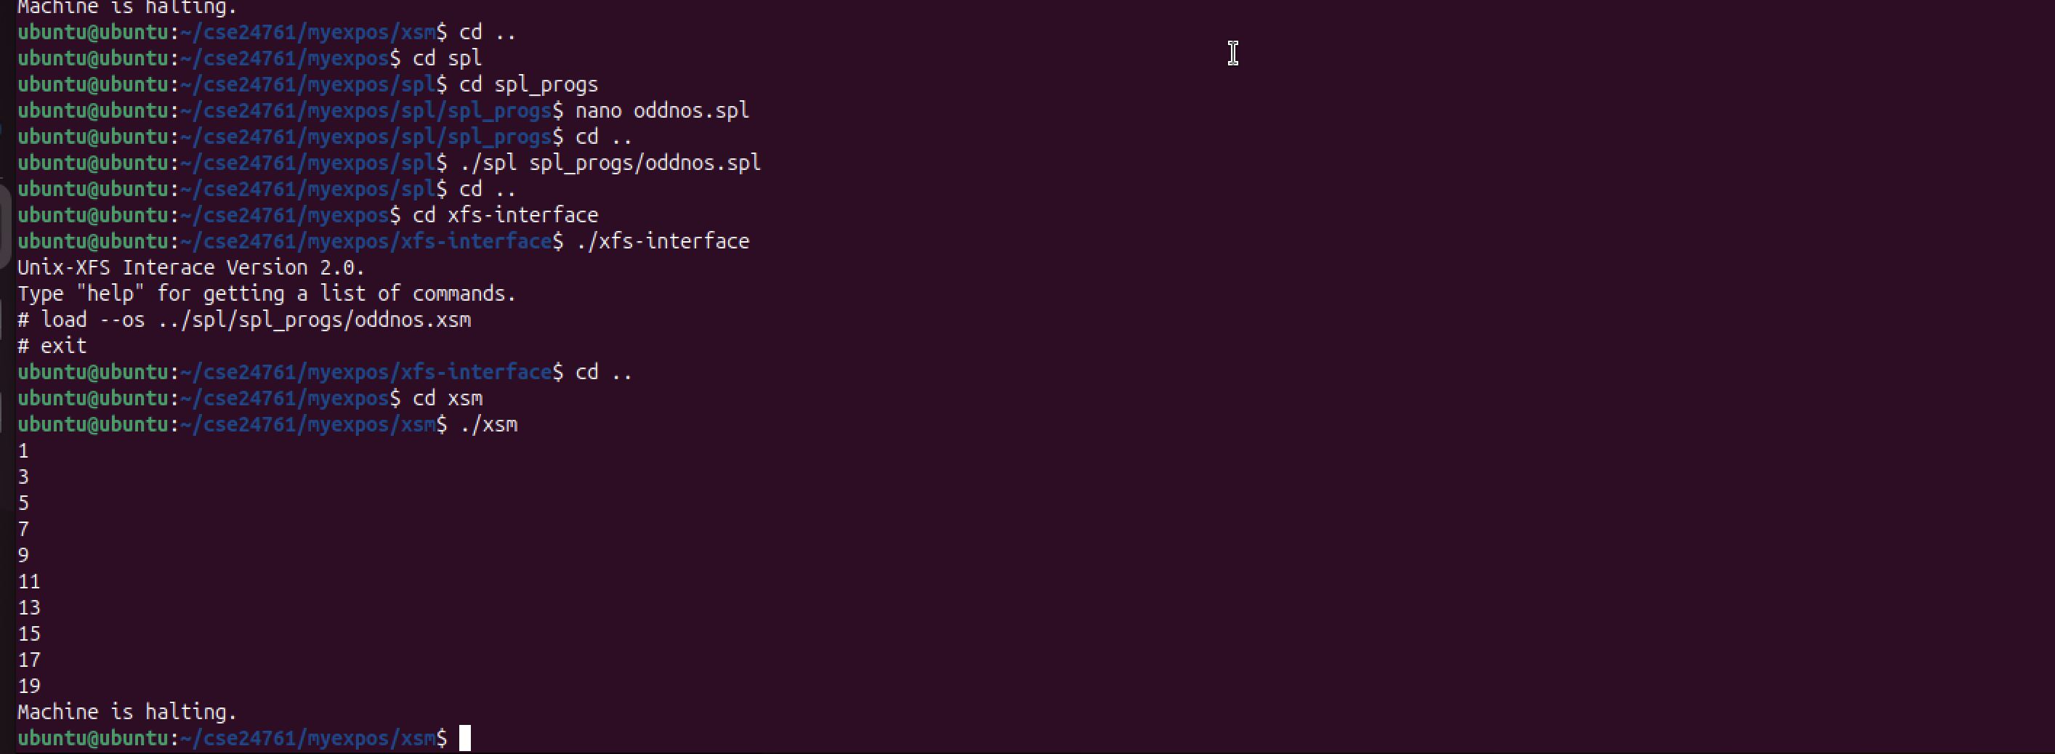

Assignment:

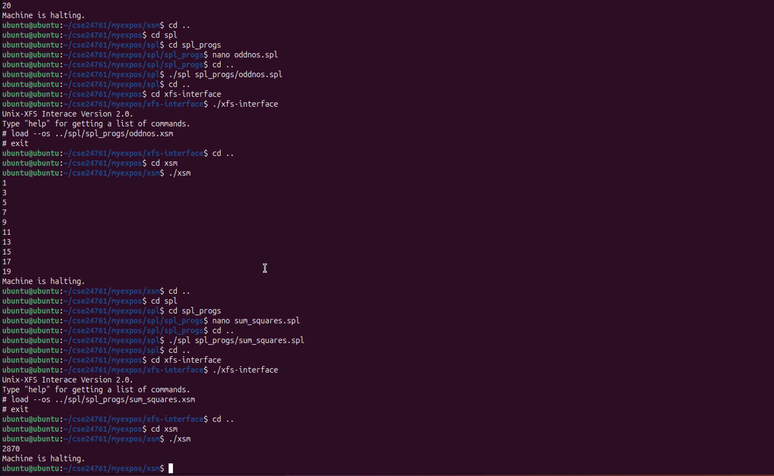

Stage 5:

ubuntu@ubuntu:~/cse24761/myexpos/xsm$ cd ..

ubuntu@ubuntu:~/cse24761/myexpos$ cd spl

ubuntu@ubuntu:~/cse24761/myexpos/spl$ cd spl_progs

ubuntu@ubuntu:~/cse24761/myexpos/spl/spl_progs$ nano odd_debug.spl

ubuntu@ubuntu:~/cse24761/myexpos/spl/spl_progs$ cd ..

ubuntu@ubuntu:~/cse24761/myexpos/spl$ ./spl spl_progs/odd_debug.spl

ubuntu@ubuntu:~/cse24761/myexpos/spl$ cd ..

ubuntu@ubuntu:~/cse24761/myexpos$ cd xfs-interface

ubuntu@ubuntu:~/cse24761/myexpos/xfs-interface$ ./xfs-interface

Unix-XFS Interace Version 2.0.

Type "help" for getting a list of commands.

# load --os ../spl/spl-progs/odd_debug.xsm

Can't open source file.

File not found.

Error while trying to delete temporary file

# load --os ../spl/spl_progs/odd_debug.xsm

# exit

ubuntu@ubuntu:~/cse24761/myexpos/xfs-interface$ cd ..

ubuntu@ubuntu:~/cse24761/myexpos$ cd xsm

ubuntu@ubuntu:~/cse24761/myexpos/xsm$ ./xsm --debug

Previous instruction at IP = 530: BRKP

Mode: KERNEL PID: -1

Next instruction at IP = 532, Page No. = 1: JMP 534

debug> r

R0: 1 R1: R2: R3: R4:

R5: R6: R7: R8: R9:

R10: R11: R12: R13: R14:

R15: R16: 1 R17: 0 R18: R19:

P0: P1: P2: P3:

BP: SP: IP: 532 PTBR: PTLR:

EIP: EC: EPN: EMA:

debug> c

Previous instruction at IP = 530: BRKP

Mode: KERNEL PID: -1

Next instruction at IP = 532, Page No. = 1: JMP 534

debug> r

R0: 3 R1: R2: R3: R4:

R5: R6: R7: R8: R9:

R10: R11: R12: R13: R14:

R15: R16: 1 R17: 0 R18: R19:

P0: P1: P2: P3:

BP: SP: IP: 532 PTBR: PTLR:

EIP: EC: EPN: EMA:

debug> c

Previous instruction at IP = 530: BRKP

Mode: KERNEL PID: -1

Next instruction at IP = 532, Page No. = 1: JMP 534

debug> r

R0: 5 R1: R2: R3: R4:

R5: R6: R7: R8: R9:

R10: R11: R12: R13: R14:

R15: R16: 1 R17: 0 R18: R19:

P0: P1: P2: P3:

BP: SP: IP: 532 PTBR: PTLR:

EIP: EC: EPN: EMA:

debug>

odd_debug.spl:

alias counter R0;

counter = 0;

while(counter <= 10) do

if(counter%2 != 0) then

breakpoint;

endif;

counter = counter + 1;

endwhile;

